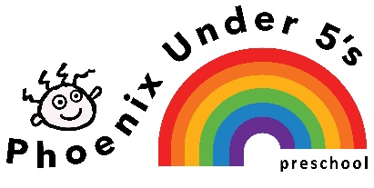
Lunchboxes – Information for parents

We are delighted that your child will be joining us for lunch. We aim that lunchtime is a happy, relaxed time where children socialise together with adults in smaller groups. We also aim that the children will be as independent in eating their lunch as possible.

Please help us by providing the following items:
- Suitable lunchbox clearly labelled with your child’s name.
- Cool/ice brick (to keep food cool and safe)
- A drink which the children can manage easily themselves- again labelled.

No peanuts, peanut butter, Nutella, other nut-based foods, chocolate, sweets or fizzy drinks.

Small children can be overwhelmed by generous amounts of food in their lunchbox, so please keep the contents small, varied and attractive.

A few ideas for packed lunches –
- Cut sandwiches into small pieces (no more than two slices of bread please) - squares, triangles or fingers are very appealing.
- Add a few cubes of cheese, pieces of carrot and cucumber, mini-sausages, cherry tomatoes, so that your child can pick and choose with ease.
- Prepare fruit by cutting apples and peeling and segmenting satsumas and oranges, then wrap them in clingfilm or put them in a small plastic pot.

We will encourage your child to eat as much as he/she wants. Any uneaten food will be put back in the lunchbox to help you to estimate how much to send in next time.

Crisps are very high in fat and salt so try to limit them by only providing them occasionally or by taking some out of the packet and putting them into a little pot.

We ask for only one sweet item to be packed in your child’s lunchbox

During the year we will update you with any information we get through the Healthy Schools initiative. You may also like to look on the Food Standards Agency website for ideas on healthy lunchboxes. Staff will be happy to offer you any advice.
Requirements are also available at www.foodstandards.agency.com.

